

**Data Structures and Algorithms**

**Lab Task**

**SUBMITTED BY:**

Hasaan Ahmad SP22-BSE-017

**SUBMITTED TO: Sir Ahmad Qasim**

Task 1:

#include <iostream>

using namespace std;

int main(){

    int terms;

    int x,y;

    cout <<"Enter the starting value: ";

    cin>>y;

    cout<<"Enter the stopping value: ";

    cin>>terms;

    int sum;

    for(int i = y; i <= terms; i++){

        sum += (i*i);

    }

    cout << "The sum is " << sum << endl;

    }

Output:

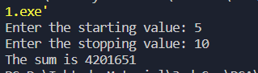

Task 2:

#include <iostream>

using namespace std;

int main(){

    int x;

    cout << "Enter the number of elements of arrays: ";

    cin>>x;

    int arr[x];

    int option;

    while(true){

    int val;

    cout<<"1: Insert the value at the end of the list: " <<endl;

    cout<<"2: Insert the value at the start of the list: " << endl;

    cout<<"3: Insert the value after specific value: "<<endl;

    cout<<"4: Insert the value before specific value: "<<endl;

    cout<<"5: Display the array List: "<<endl;

    cout<<"6: Delete the value from end of the list: " <<endl;

    cout<<"7: Delete the value from the start of the list"<<endl;

    cout<<"8: Delete the specific value"<<endl;

    cout<< "Choose the option from 1 - 8"<<endl;

    cin>>option;

    switch(option){

        case 1:

            cin>>val;

            arr[x-1] = val;

            break;

        case 2:

            cin>>val;

            arr[0] = val;

            break;

        case 3:

            cin>>val;

            cout << "Enter a specific Value:";

            int elem;

            cin >>elem;

            arr[val]=elem;

            break;

        case 4:

            cin>>val;

            cout << "Enter a specific Value:";

            int elem2;

            cin >>elem2;

            arr[val-1]=elem2;

            break;

        case 5:

            for(int i=0;i < x;i++){

                cout <<arr[i] << endl;

            }

            break;

        case 6:

            cin>>val;

            arr[x-1] = 0;

            break;

        case 7:

            cin>>val;

            arr[0] = 0;

            break;

        case 8:

            cin>>val;

            arr[val-1] = 0;

            break;

        default:

            cout<<"Please choose a valid option: ";

    }

}

}

Output:

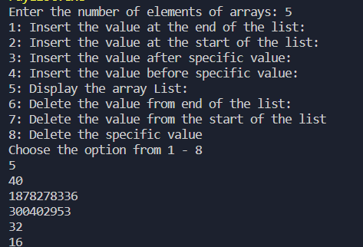

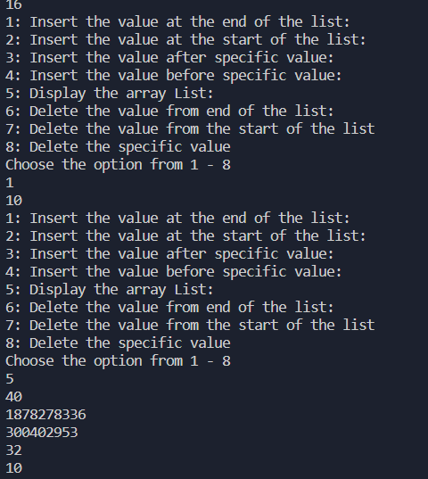

Task 2b:

// HASAAN AHMAD

// SP22-BSE-017

#include<iostream>

#include<list>

using namespace std;

// METHOD TO PRINT LIST

void showlist(list<int> g)

{

    list<int>::iterator it;

    for (it = g.begin(); it != g.end(); ++it)

        cout << '\t' << *it;

    cout << '\n';

}

// MAIN METHODS

int main()

{

    list<int> myList = {23,4,35,65};

    // TO ACCESS THE LAST ELEMENT

    cout<<myList.back();

    // To Insert in the end

    myList.emplace_back(30);

    showlist(myList);

    // To insert in the start

    myList.emplace_front(20);

    showlist(myList);

    // Insert at specific position

    // Takes pointer

    auto it = myList.begin();

    // ADVANCING THE ITERATOR

    advance(it,2);

    myList.emplace(it,15);

    showlist(myList);

    // To remove first element

    myList.pop_front();

    showlist(myList);

    // To remove last element

    myList.pop_back();

    showlist(myList);

// TO REMOVE AT SPECIFIC PLACE

    it = myList.begin();

    advance(it,2);

    myList.erase(it);

    showlist(myList);

// NICELY DONE SEE YA LATER

    return 0;

}

Output:

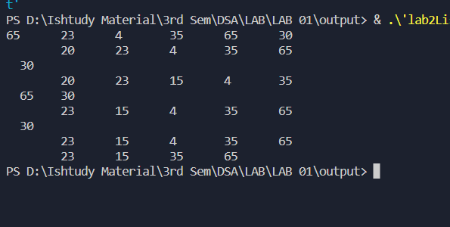

Task 3:

#include <iostream>

using namespace std;

int main() {

   int arr[] = { 3, 5, 2, 8, 1, 9 };

   int n = sizeof(arr) / sizeof(arr[0]); // Calculate the size of the array

   int key = 8; // Element to search

   int i = 0;

   while (i < n && arr[i] != key) {

      i++;

   }

   if (i < n) {

      cout << "Element found at index " << i << endl;

   }

   else {

      cout << "Element not found" << endl;

   }

   return 0;

}

Output:

